Jsp Include Directive

The include directive is used to include the contents of any resource it may be jsp file, html file or text file. The include directive includes the original content of the included resource at page translation time (the jsp page is translated only once so it will be better to include static resource)

### **Advantage of Include directive**

Code Reusability

### **Syntax of include directive**

1. <%@ include file="resourceName" %>

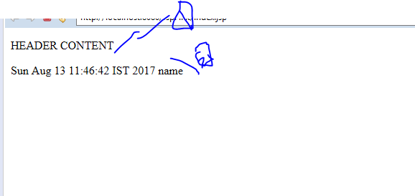

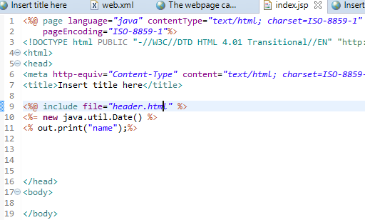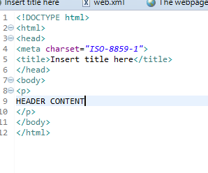

Syntax of jsp:include action tag without parameter

<jsp:include page="relativeURL | <%= expression %>" />

Syntax of jsp:include action tag with parameter

<jsp:include page="relativeURL | <%= expression %>">

<jsp:param name="parametername" value="parametervalue | <%=expression%>" />

</jsp:include>

# Exception Handling in JSP-

The exception is normally an object that is thrown at runtime. Exception Handling is the process to handle the runtime errors. There may occur exception any time in your web application. So handling exceptions is a safer side for the web developer. In JSP, there are two ways to perform exception handling:

1. By **errorPage** and **isErrorPage** attributes of page directive
2. By **<error-page>** element in web.xml file

### **Example of exception handling in jsp by specifying the error-page element in web.xml file**

# This approach is better because you don't need to specify the errorPage attribute in each jsp page. Specifying the single entry in the web.xml file will handle the exception

There are 4 files:

* web.xml file for specifying the error-page element
* index.jsp for input values
* process.jsp for dividing the two numbers and displaying the result
* error.jsp for displaying the exception

